1

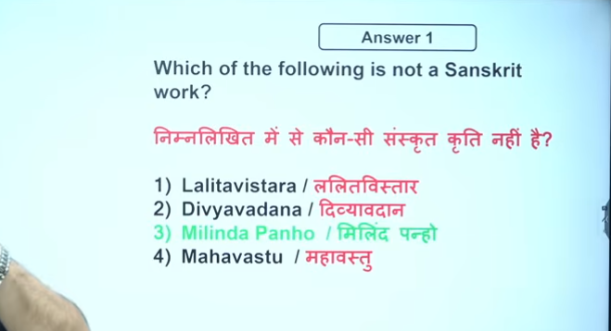

[*Milindapanho*](https://www.google.com/search?q=Milindapanho&oq=milindi+panho+wr&gs_lcrp=EgZjaHJvbWUqCQgBEAAYDRiABDIGCAAQRRg5MgkIARAAGA0YgAQyCQgCEAAYDRiABDIICAMQABgNGB4yCAgEEAAYDRgeMggIBRAAGA0YHjIKCAYQABgIGA0YHjIHCAcQABjvBdIBCTk1MTBqMGoxNagCCLACAfEFSfvRVQy629s&sourceid=chrome&ie=UTF-8&ved=2ahUKEwi36ea2-uWSAxVbcGwGHYUpL-cQgK4QegYIAQgAEAU) (or Milinda Panha), a foundational Pali text from the 1st/2nd century BC–AD, is a recorded dialogue written by the Buddhist sage **[Nagasena](https://www.google.com/search?q=Nagasena&oq=milindi+panho+wr&gs_lcrp=EgZjaHJvbWUqCQgBEAAYDRiABDIGCAAQRRg5MgkIARAAGA0YgAQyCQgCEAAYDRiABDIICAMQABgNGB4yCAgEEAAYDRgeMggIBRAAGA0YHjIKCAYQABgIGA0YHjIHCAcQABjvBdIBCTk1MTBqMGoxNagCCLACAfEFSfvRVQy629s&sourceid=chrome&ie=UTF-8&ved=2ahUKEwi36ea2-uWSAxVbcGwGHYUpL-cQgK4QegYIAQgAEAc)**. It documents conversations on Buddhist philosophy, ethics, and metaphysics between Nagasena and the Indo-Greek King Menander I (Milinda) of Bactria. 

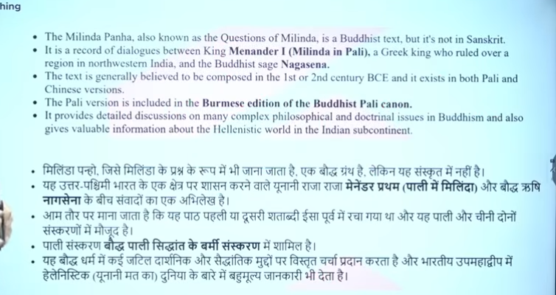

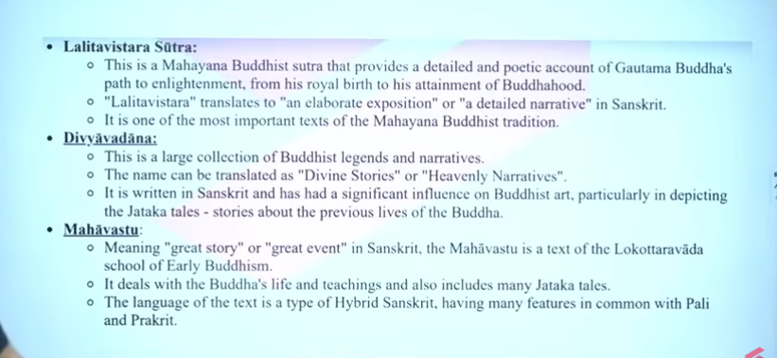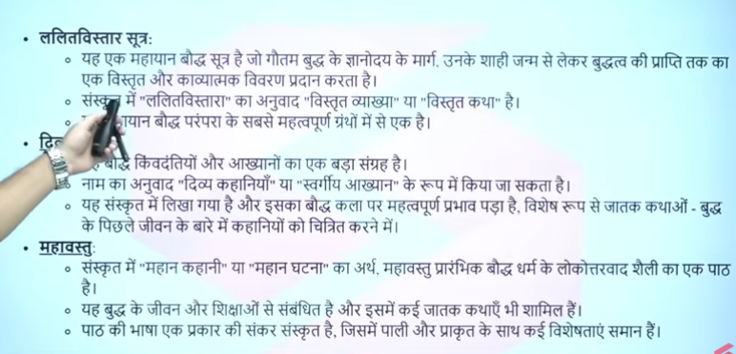

2

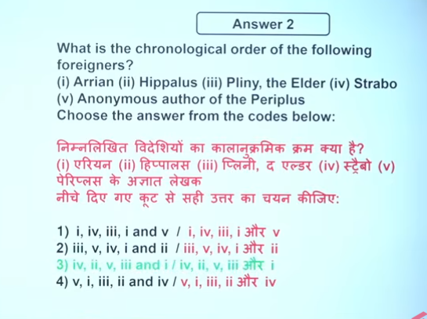

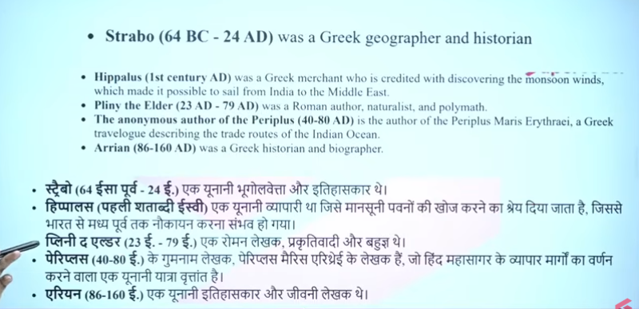

3

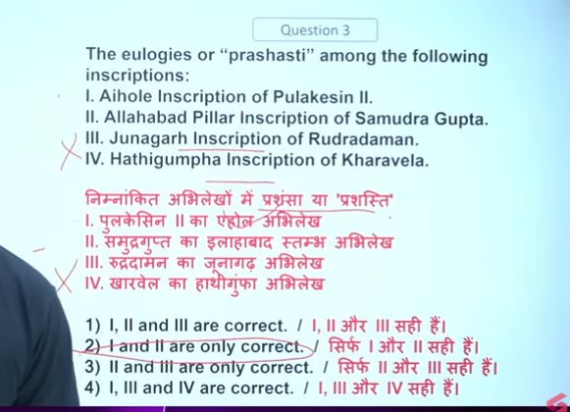

4

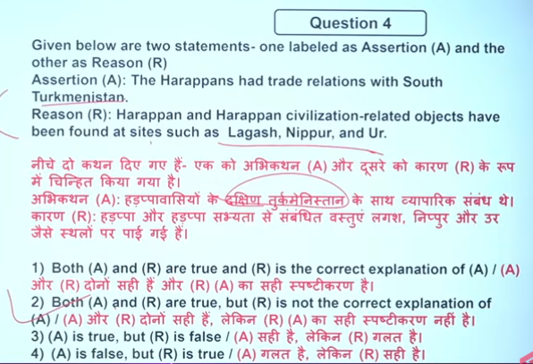

5

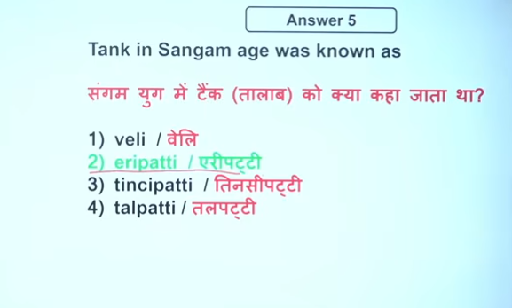

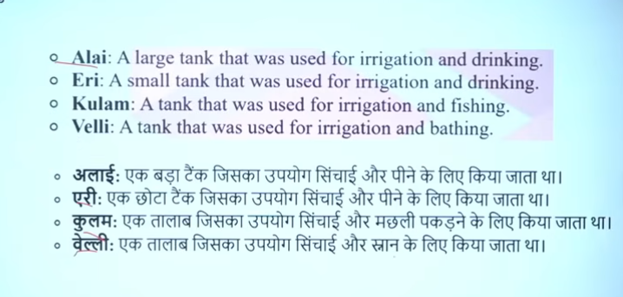

6

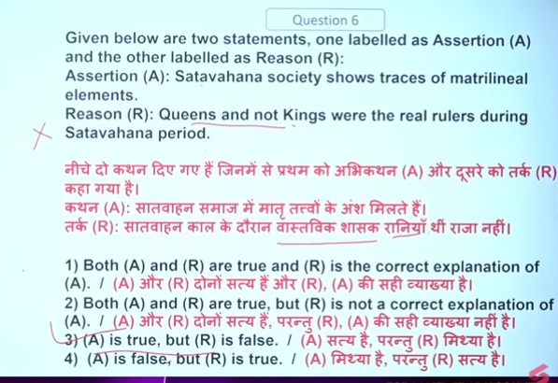

7

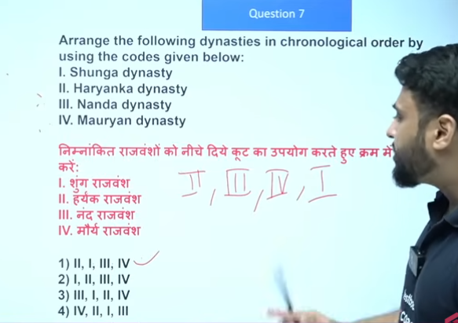

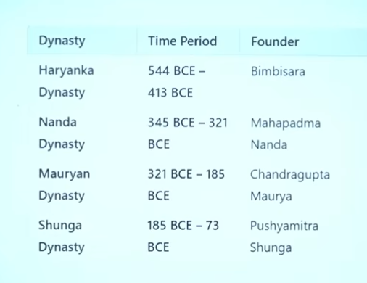

8

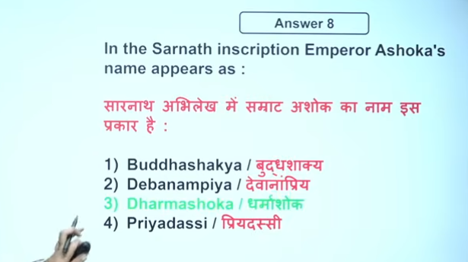

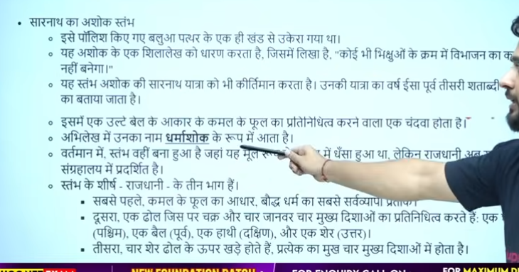

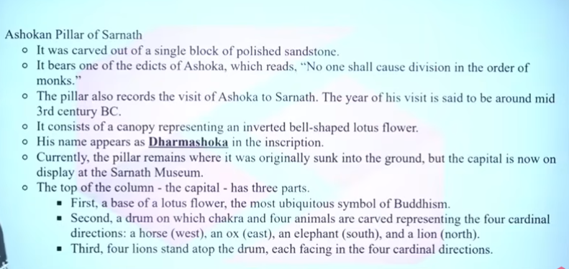

9

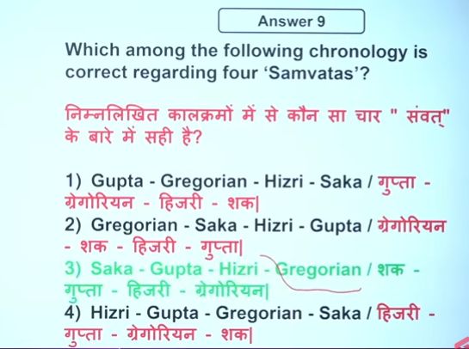

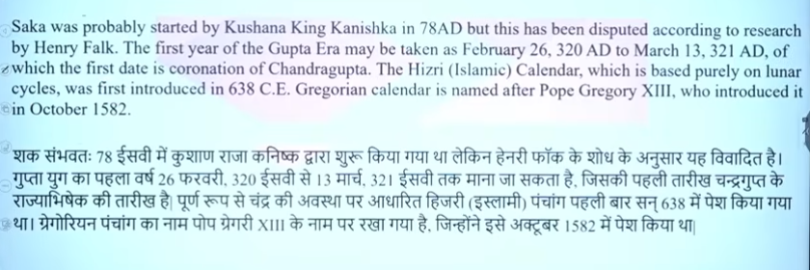

10

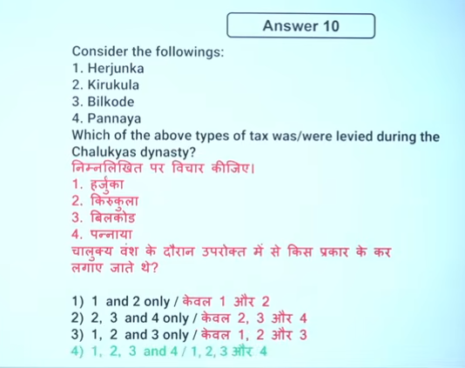

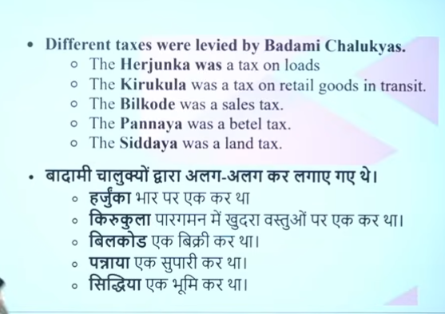

Q.11

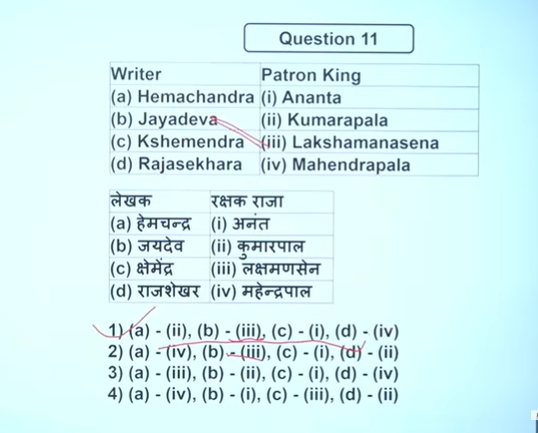

12

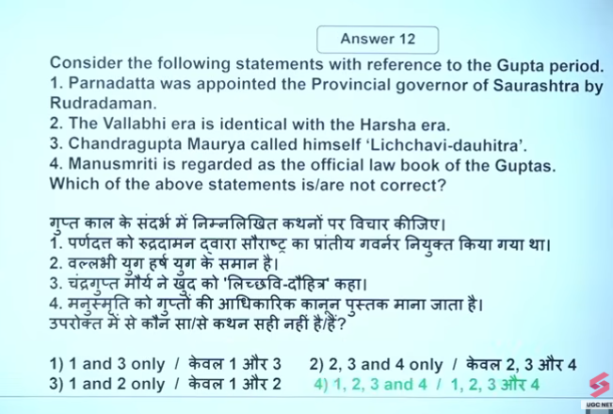

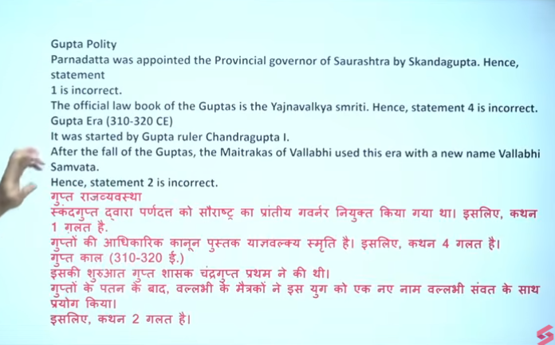

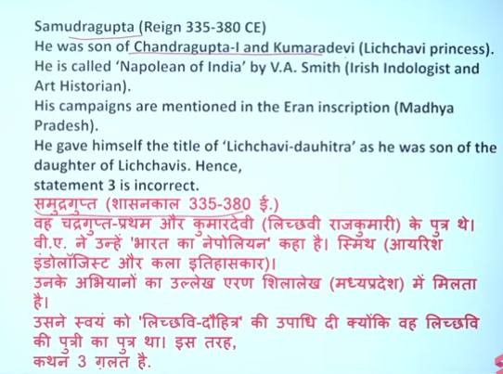

13

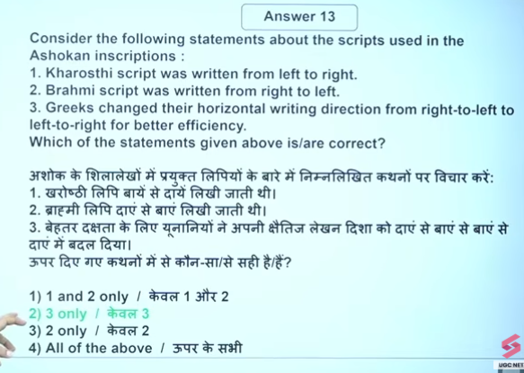

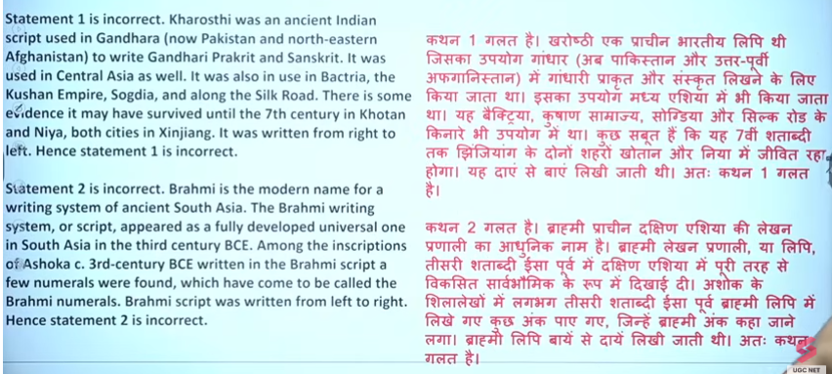

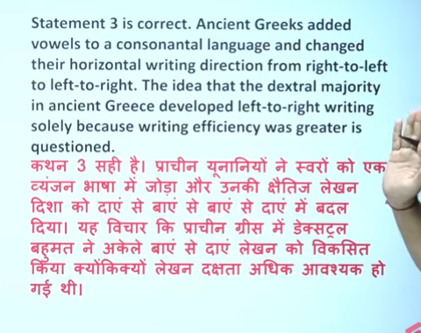

14

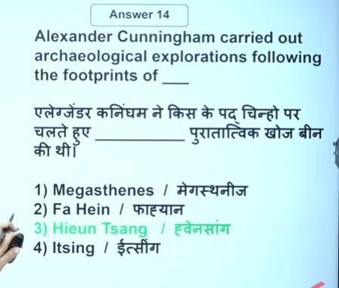

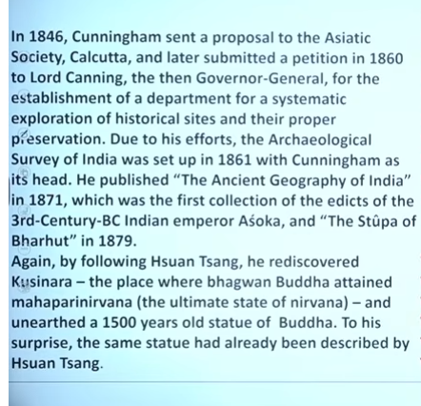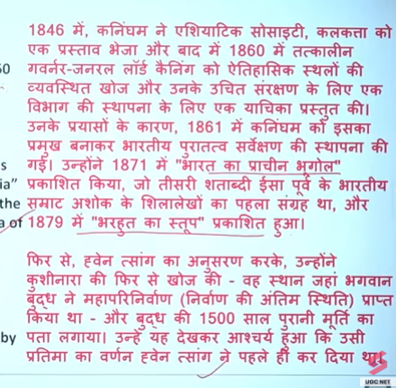

15

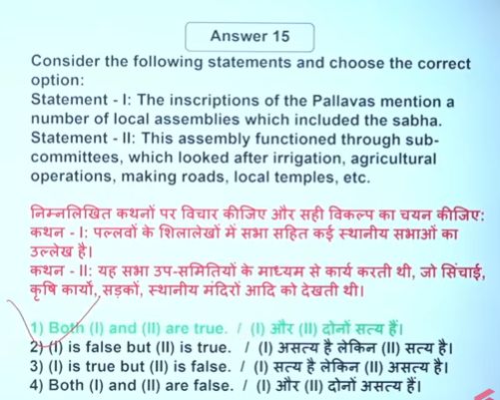

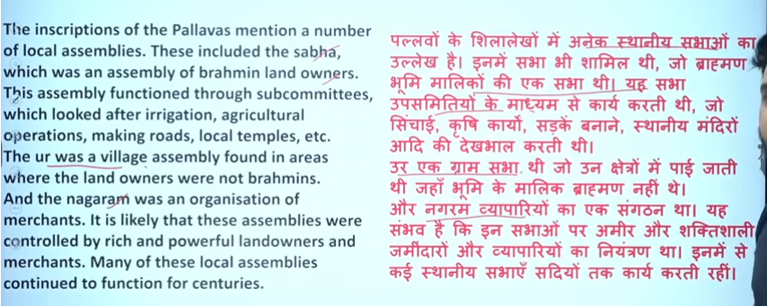

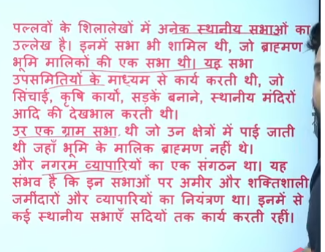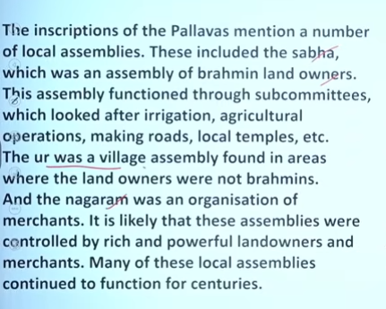

16

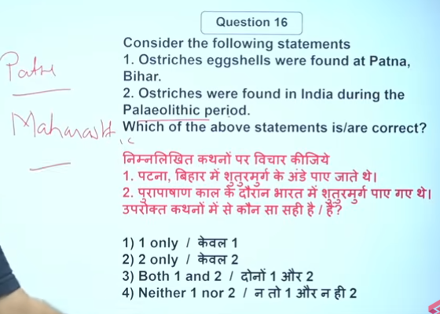

17

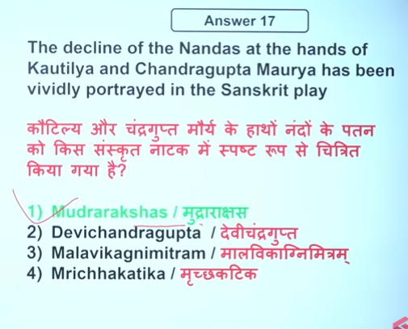

Q.18

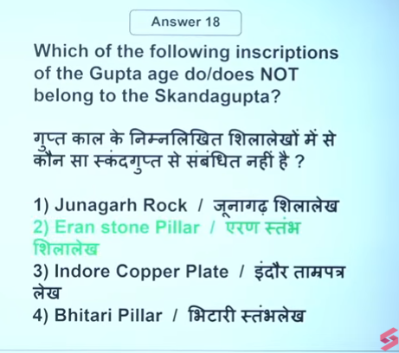

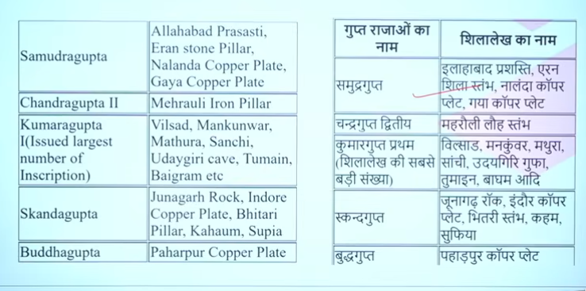

19

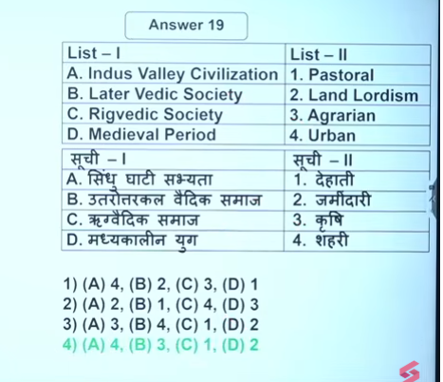

20

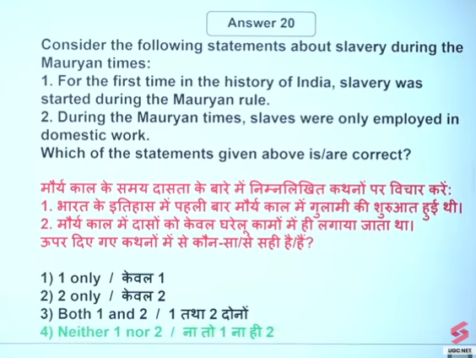

21

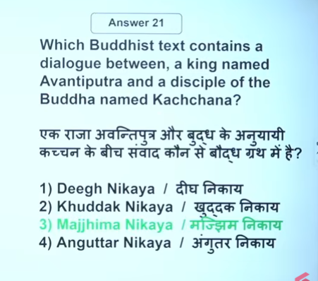

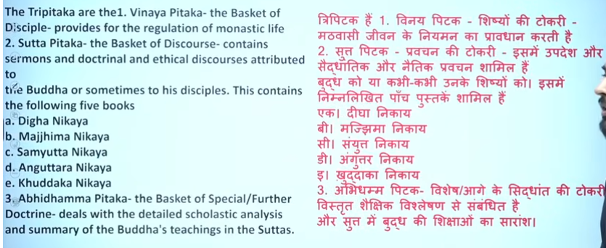

22

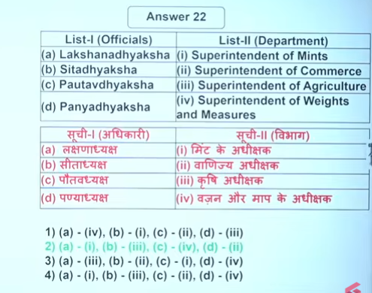

23

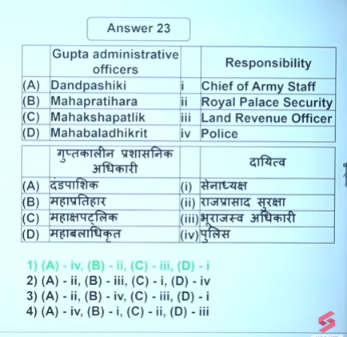

24

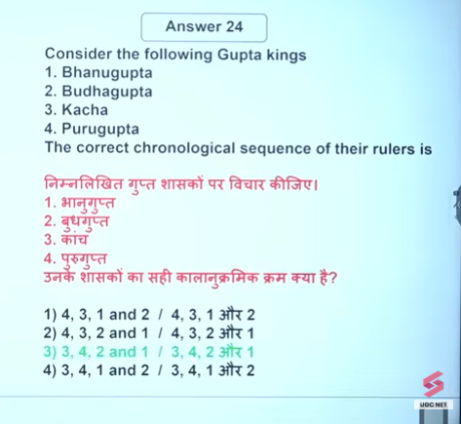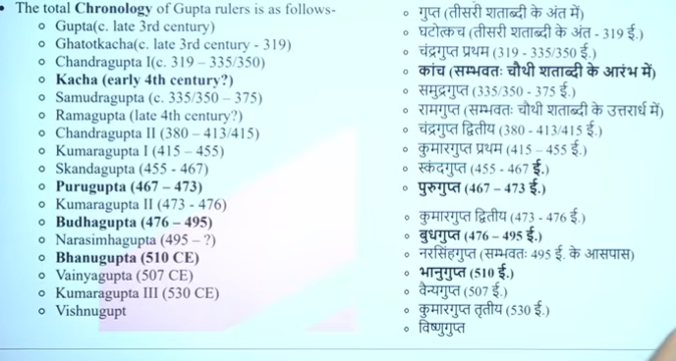

25

